**Caroline Kennedy Library, Dearborn Heights, MI**

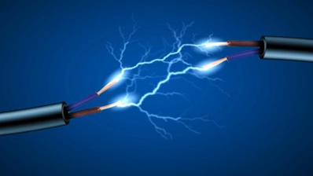

**Students:** Welcome to the free introduction to the fundamentals of electricity class:

**NOTE: Classes are limited to only 12 students, so register early.**

The class schedule is below.

Registered students will receive an e-mail a copy of the detailed outline for the course.

Review through the class material and on line training before each class, so we can focus our discussions anything that requires more detailed explanation and move on to the fun “hands on” experiments.

All classes are held on Mondays from 7 PM to 8:30 PM.

Please be a few minutes early to ‘sign in’ for the start of each class.

**Class Schedule:**



**Before each class:** **Students and instructors review an on-line tutorial(s) covering the basic skills required as background for each topic, (**Details for each class will be sent by e-mail before each class**.)**

**Class Timing:**

* 6:30: Instructors arrive, setup and prepare for class.
* 6:45: Students arrive and register with librarian representative.
* 7:00: In-Class discussion with a quick review of the ‘on-line’ tutorial topics to answer any immediate questions.
* 7:15: Class discussion of the scheduled topics and demonstrations.
* 7:30: “Hands on” experimentation by students to demonstrate the results of putting the tutorial information into practice.
* 8:15: Clean up and store any experimental materials
* 8:30: Class discussion to review how the experiments related to the pre-class tutorial information.
* 8:45: Class dismissed
* 8:45: Instructors pack up equipment, clean room, depart.

Classes conducted at the:

**Caroline Kennedy Library**

**24590 George Street**

**Dearborn Heights, MI 48127**