**Amateur Radio Safe Soldering Classes @ the Bacon Memorial Library**

**The Wyandotte Bacon Memorial Library and the Motor City Radio Club will present a FREE 10 part series to learn how to Solder Safely and build your first, low cost, CW Amateur Radio station.**

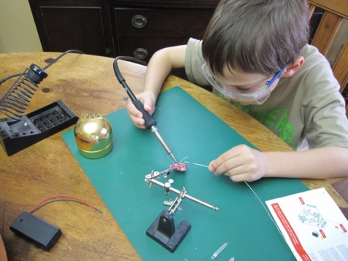**Classes will begin Saturdays from**

**March 2nd @ 1 PM – 3:30 PM.**

Class size is limited to 10 students, so please register early.

Join us and open the doorway to the world.

Download and read through the following before class:

**http://www.elecraft.com/TechNotes/N0SS_SolderNotes/N0SS_SolderNotesV6.pdf**

**Please register early for the classes at the reference desk, or by phone or at the library as the class size is limited. Patrons may also register online from the library's website at Baconlibrary.org. Use the Event button then select**

**March 2nd and the Safe Soldering Class.**

**Bacon Memorial District Library,** 45 Vinewood, Wyandotte, MI 48192**,** Phone: **734-246-8357**

**Safe Soldering Classes:**

We will provide all the equipment necessary to learn how to solder safely, instruction and oversight during assembly, and help you with the final check out to ensure proper functioning of each kit.

**Schedule & Kit Types:**

**Ham Radio Equipment Costs:**

There is a misconception that Amateur Radio is a ‘rich man’s hobby’. While it is possible to spend as much as you could afford on any hobby, Amateurs learn to assemble inexpensive equipment costing less than $150 that can ‘work the world’ from your back yard.

Students purchase their own kits. We will assist you, and we will help if you want to make substitutions for different kit modules. However, since there it takes time to order and receive the kits, we need to know if there will be any changes at least two weeks before the class.

**The first 6 kits above may be ordered ‘on line’ from: http://qrpguys.com/**

**Amateur Radio Kit Examples:**

Here are a few of the Amateur Radio kits we will assist you to build as you learn to solder safely and effectively, trained by some our most experienced ‘Ham’ radio builders.

This ‘Dummy Load/Power Meter’ provides an RF load while testing a radio transmitter and allowing a measurement of the output power.



This ‘Half Wave Antenna Tuner’ will allow the use of a long wire up in a tree and a short ground wire to become an effective antenna for out-door radio fun at a picnic, or camping outing.



The Single Lever Keyer/Paddle at the right generates Morse code dots and dashes allowing good sending quality even among beginners. It also doubles as a code practice oscillator and memory keyer.

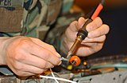

The kits we recommend to use to learn safe soldering are available through: **http://qrpguys.com/**

Order the first two kits above (‘Dummy Load/Power Meter’, and ‘Half Wave Antenna Tuner’ at least two weeks before class to be sure you have them with you to use when we begin class.

**Why Morse Code?**

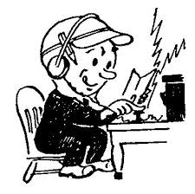***“I thought Morse Code was no longer required for a Ham license.***

***Why learn to use the Code?”***

Good question. The use of Morse Code (CW) is growing as more Hams discover how much fun it can be, as well as a reliable communication method in case of emergencies.

But, most continue to use it just because it is fun.

We will recommend some free on-line training sites where anyone can learn to send and receive Morse Code to assist in the short lessons at the end of each license and soldering class.

N8FNC Kim