**Amateur Radio Classes @ the Bacon Memorial Library**

**The Wyandotte Bacon Memorial Library and the Motor City Radio Club will present a FREE 8 part series of Amateur Radio license classes finishing with an examination to obtain your Amateur Radio license.**

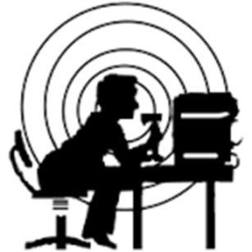**Classes will begin Saturdays starting on March 9th @ 10 AM**

**An optional Exam will be given on week 8.**

We will provide students with lists of other sites and dates where they may take the test.

(The license examination fee is always $15.00.)

Class size is limited, so please register early.

Join us and open the doorway to the world.

**Please register early for the classes at the reference desk, or by phone or at the library as the class size is limited. Patrons may also register online from the library's website at Baconlibrary.org. Use the Event button then select**

**March 9th and the Amateur Radio Class.**

**Bacon Memorial District Library,** 45 Vinewood, Wyandotte, MI 48192**,** Phone: **734-246-8357**

**Amateur Radio License Classes:**

We will be using the FREE “**No-Nonsense Technician Class License Study Guide**”

by **Dan Romanchick, KB6NU**.

This is a free down load of 58 pages in PDF format available at **www.kb6nu.com/study-guides/**.

Or … printed copies can be ordered at Amazon.com for under $15.

**Class Costs:**

* Text (Download and print, or read on-line) Free
* Instruction (Motor City Radio Club ‘Hams’) Free
* Final class ‘FCC’ Exam $15.00 (*Exam fee is always the same.)*



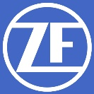

**What is Ham Radio all about?**

“Amateur Radio (ham radio) is a popular hobby and service that brings people, electronics and communication together. People use ham radio to talk across town, around the world, or even into space, all without the Internet or cell phones. It's fun, social, educational, and can be a lifeline during times of need.

Although Amateur Radio operators get involved for many reasons, they all have in common a basic knowledge of radio technology and operating principles, and pass an examination for the FCC license to operate on radio frequencies known as the "Amateur Bands." These bands are radio frequencies allocated by the Federal Communications Commission (FCC) for use by ham radio operators.

Amateur Radio operators come from all walks of life -- doctors, students, kids, politicians, truck drivers, movie stars, missionaries and even your average neighbor next door. They are of all ages, sexes, income levels and nationalities. Whether through Morse Code on an old brass telegraph key, voice communication on a hand-held radio or computerized messages transmitted via satellite, all hams use radio to reach out to the world.

Some hams like to build and experiment with electronics. Computer hobbyists enjoy using Amateur Radio's digital communications opportunities. Others compete in "DX contests," where the object is to see how many hams in distant locations they can contact. Mostly we use ham radio to form friendships over the air or through participation in one of more than 2000 Amateur Radio clubs throughout the country. There are over 700,000 radio amateurs in the United States and over 2,000,000 worldwide.”

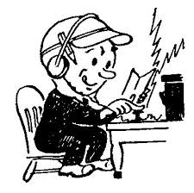ARRL

**Why Morse Code?**

***“I thought Morse Code was no longer required for a Ham license.***

***Why learn to use the Code?”***

Good question. The use of Morse Code (CW) is growing as more Hams discover how much fun it can be, as well as a reliable communication method in case of emergencies.

But, most continue to use it just because it is fun.

We will recommend some free on-line training sites where anyone can learn to send and receive Morse Code to assist in the short lessons at the end of each license class.

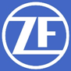

N8FNC Kim